ACKNOWLEDGMENT
I would like to express my sincere gratitude to my project guide and the faculty members of the Department of Computer Engineering for their valuable guidance, encouragement, and continuous support throughout the duration of this project titled “HandSpeak.” Their expert insights and constructive feedback greatly contributed to the successful completion of this work.
I am also thankful to the Head of the Department for providing the necessary facilities, resources, and a conducive learning environment to carry out this project.
I would like to extend my appreciation to my classmates and friends for their cooperation, helpful suggestions, and motivation during the development and testing phases.
Finally, I am deeply grateful to my family for their constant support, understanding, and encouragement, which kept me focused and motivated throughout the project

ABSTRACT
HandSpeak is an AI-based real-time sign language recognition system designed to assist individuals with hearing and speech impairments. The system captures hand gestures through a camera and processes them using computer vision techniques such as MediaPipe for landmark detection. A Convolutional Neural Network (CNN) model classifies these gestures into meaningful sign labels.
To enhance communication, the system integrates an AI Assistant that generates relevant sentences based on recognized gestures, making the interaction more natural and context-aware. The output is displayed as text and further converted into speech using a text-to-speech module, enabling seamless gesture-to-speech translation.
Security measures, including JWT-based authentication, encrypted data handling, and role-based access control, ensure the safety and reliability of the system. HandSpeak demonstrates how deep learning, artificial intelligence, and computer vision can be combined to build an accessible, inclusive, and practical assistive technology.
The project has strong potential for future enhancements such as expanded gesture datasets, mobile deployment, cloud-based analytics, and a voice-to-sign module.

INDEX OF THE PROJECT REPORT (B. Tech CEs & IT SEM VII)

SR. NO. | CONTENTS | PAGE NO.
* | Acknowledgment | I
* | Abstract | II
* | Index of the project report | III
* | List of Figures | V
* | List of Tables | VI
1 | ABOUT THE SYSTEM: | (1)
1.1 | Problem definition (Identification of needs):
1.2 | Requirement Specifications (Product/System Tasks)
1.3 | Tools and Technology Used (FrontEnd/Back-  End/Framework/Protocol/API/Services/App. etc.).
1.4 | Existing vs Proposed System
2 | SYSTEM DESIGN USING UML: | (10)
2.1 | Data Flow Diagrams
2.2 | Use Case Diagram.
2.3 | Class Diagram.
2.4 | Sequence Diagrams.
2.5 | System Architecture Diagram
3 | DATA DICTIONARY: | (14)
3.1 | Database tables SQL/NoSQL
4 | IMPLEMENTATION: | (15)
4.1 | Screen Layouts with validations.
4.2 | Sample Coding (with Security tasks).
4.3 | Steps of the execution Project and Navigation.
4.4 | Model Training & Evaluation Results
4.5 | Python Code
5 | CONCLUSION: | (28)
5.1 | Importance of the worked-out tasks
5.2 | Further Enhancement in future.
6 | REFERENCES: | (30)
6.1 | Books, Research Papers, Experts persons, Technology, Webs, etc.

Note: Here minimum pages are counted (Must be up to 30 pages, excluding Roman pages), further you can increase according to your requirements completion.

Project Coordinator: Head of the School

LIST OF FIGURES
Fig 2.1 DFD Level 0 — Context Diagram
Fig 2.2 DFD Level 1
Fig 2.3 DFD Level 2
Fig 2.4 Use Case Diagram
Fig 2.5 Class Diagram
Fig 2.6 Sequence Diagram
Fig 2.7 System Architecture Diagram

LIST OF TABLES
Table 1.1 Functional Requirements
Table 1.2 Non-Functional Requirements
Table 1.3 Tools and Technologies Used
Table 3.1 Users Table
Table 3.2 Logs Table
Table 3.3 Sessions/Auth Table
Table 4.1 Model Performance Metrics
Table 4.2 Security Features Implemented
Table 4.3 API Endpoints and Security Levels

1. ABOUT THE SYSTEM

1.1 Problem Definition

A. Communication Gap Between Signers and Non-Signers
- Sign language is not universally understood by the general population.
- Most people cannot interpret gestures fluently, leading to frequent miscommunication.
- This gap causes difficulties in daily interactions such as:
  - Hospitals and emergency services
  - Workplaces and offices
  - Schools and educational institutes
  - Government departments
  - Public service centers and shops
- The lack of mutual understanding results in frustration, confusion, and reduced accessibility.

B. Limitations of Traditional Communication Methods
- Human interpreters are helpful but:
  - Not always available
  - Expensive
  - Not practical for day-to-day, real-time communication
- Text-based communication can be slow, inconvenient, and unnatural.
- Many mobile apps require:
  - Pre-recorded gesture videos
  - Manual input
  - Delays in processing
- Existing tools often lack natural language understanding and produce robotic or incomplete output.

C. Lack of Affordable and Real-Time Assistive Technology
- Modern gesture-recognition systems often depend on special hardware like:
  - Sensor gloves
  - Depth cameras
  - Kinect sensors
- These devices are costly and not suitable for everyday users.
- The ideal system must work on:
  - Regular smartphone cameras
  - Laptop webcams
  - Without extra equipment
- Many current solutions do not offer instant, smooth, real-time gesture processing.

D. Privacy and Security Concerns
- Camera-based systems must ensure data privacy to build user trust.
- Sensitive user information must be protected using:
  - Encrypted storage
  - Secure authentication
- Many existing applications lack modern security standards.

E. Social, Emotional, and Practical Barriers
- Deaf or mute individuals face difficulty expressing themselves freely.
- They may feel misunderstood in professional and social settings.
- Communication dependency reduces confidence and independence.
- This often leads to:
  - Delayed conversations
  - Misinterpretations
  - Social exclusion
  - Limited opportunities

F. Need for an Automated, Real-Time Sign Language Interpretation System
- A system is urgently needed that:
  - Detects gestures instantly
  - Translates signs to text accurately
  - Generates meaningful sentences
  - Converts text into speech
- The solution must be accessible, low-cost, secure, and easy to use.
- It should empower individuals with speech or hearing impairments to communicate independently.

How HandSpeak Solves the Problem
HandSpeak is designed as a complete, real-time, AI-powered communication solution that eliminates the barriers faced by sign language users. The system uses cutting-edge technologies—computer vision, deep learning, and AI communication models—to translate gestures into understandable text and speech instantly. Here is how HandSpeak addresses each aspect of the problem:

1. Real-Time Gesture Recognition Using Regular Camera
HandSpeak uses the device’s built-in camera, eliminating the need for expensive hardware or wearable devices. With MediaPipe, the system extracts 21 hand landmarks and tracks them dynamically in real-time.
This ensures:
- No need for special sensors
- Minimal setup
- High accuracy even in normal lighting

2. Accurate Sign Classification Using a CNN Model
A trained Convolutional Neural Network (CNN) processes normalized hand landmarks and predicts the corresponding sign with high accuracy.
The CNN model:
- Learns unique gesture patterns
- Differentiates between multiple signs
- Responds within milliseconds
This enables fast and accurate identification of signs.

3. Converts Gestures Into Natural Language (AI Assistant)
Unlike many applications that only output one-word sign labels, HandSpeak integrates an AI Assistant that generates complete, meaningful sentences.
Example:
Gesture: “THANK YOU”
AI Output: “Thank you! Let me know if you need anything else.”
This makes communication smoother, clearer, and more natural for general users.

4. Gesture-to-Speech Conversion
After generating the text output, the system uses Text-to-Speech (TTS) to convert it into clear audio.
This allows:
- People who do not know sign language to hear the communication
- Deaf/mute individuals to “speak” in public through AI assistance

5. Secure Access Using JWT Authentication
To ensure privacy and protect user data:
- Login access is secured with JWT tokens
- Passwords are hashed with bcrypt
- Role-based access restricts admin actions
This ensures the system meets modern security standards.

6. Logging & Feedback for Continuous Improvement
Each recognized gesture can be stored in logs for:
- Model performance monitoring
- User interaction analysis
- Future dataset expansion
This enables the system to evolve over time.

7. Fully Scalable for Mobile, Desktop & IoT
HandSpeak is designed to be:
- Extendable to Android/iOS applications
- Usable with IoT-based gesture gloves
- Deployable in cloud environments
This scalability ensures the project can grow into a large assistive technology product.

1.2 Requirement Specifications

Table 1.1 – Functional Requirements
Requirement ID | Functional Requirement | Description
FR-01 | User Authentication | User must log in using secure credentials.
FR-02 | Camera Access | System must capture video input.
FR-03 | Hand Landmark Detection | Extract 21 keypoints using MediaPipe.
FR-04 | Gesture Preprocessing | Basic image filtering and normalization.
FR-05 | Gesture Classification | CNN classifies gesture tokens.
FR-06 | Real-Time Output | Display recognized sign instantly.
FR-07 | AI Assistant Suggestion | Generate meaningful sentences.
FR-08 | Text-to-Speech Output | Convert final text into speech.
FR-09 | Logging | Store recognized gestures securely.
FR-10 | Admin Panel | Role-based admin access.

Table 1.2 – Non-Functional Requirements
Requirement ID | Non-Functional Requirement | Description
NFR-01 | Performance | Frame processing < 200ms
NFR-02 | Accuracy | CNN accuracy > 90%
NFR-03 | Security | JWT-secured endpoints
NFR-04 | Scalability | More gestures can be added
NFR-05 | Usability | Simple user interface
NFR-06 | Reliability | Should work continuously
NFR-07 | Portability | Support on multiple OS
NFR-08 | Maintainability | Modular clean code

1.3 Tools and Technologies Used

Table 1.3 – Tools and Technologies Used
Category | Tool | Purpose
Programming | Python | Backend & ML
CV Tools | MediaPipe, OpenCV | Hand landmark detection
ML Framework | TensorFlow/Keras | CNN model
Web UI | Streamlit | Frontend
Security | JWT, bcrypt | Secure login
Database | SQLite/MongoDB | Data storage
API | TTS API | Speech output
Backend | Flask/FastAPI | System services

1.4 EXISTING SYSTEM VS PROPOSED SYSTEM
Understanding how current solutions work and how HandSpeak improves upon them is important for identifying the system’s value, innovation, and technical advantage. This section compares the existing methods of sign language interpretation with the proposed HandSpeak system.

A. Existing System (Current Approach)
The existing methods used for communication with individuals who rely on sign language include:

1. Human Interpreters
- Interpreters convert sign language into spoken words.
- Availability is very limited and often costly.
- Not suitable for everyday or emergency situations.
- Dependency on another person reduces user independence.

2. Gesture-Recognition Mobile Apps
- Many apps require pre-recorded videos or manual input.
- Real-time gesture detection is often slow or inaccurate.
- Most do not support natural language generation.
- Limited gesture datasets reduce recognition accuracy.

3. Hardware-Based Solutions
- Gloves with sensors, Kinect, and depth cameras.
- High cost, difficult to carry and maintain.
- Not user-friendly for daily usage.
- Often bulky and require special environments.

4. Text-Based Communication
- Users type messages manually on devices.
- Slower and inconvenient for real-time conversations.
- Lacks emotional tone and expressive details.

5. Lack of Security in Existing Tools
- Many apps do not encrypt user data.
- No proper authentication process.
- Weak privacy measures for camera-based systems.

B. Limitations of the Existing Systems
- Lack of real-time gesture recognition.
- Heavy dependency on professional interpreters.
- High cost of specialized hardware.
- Limited flexibility and poor user experience.
- Insufficient support for natural language output.
- No integrated gesture-to-speech conversion.
- Weak or absent security mechanisms.

C. Proposed System (HandSpeak)
The proposed system aims to eliminate these limitations through an AI-powered real-time platform:

1. Real-Time Gesture Recognition
- Uses MediaPipe and a webcam (no extra hardware).
- Detects 21 hand landmarks per frame.
- Fast and accurate gesture classification using CNN.

2. AI-Assisted Text Generation
- Converts gesture outputs into meaningful sentences.
- Ensures smooth and natural communication.

3. Gesture-to-Speech Output
- Converts AI-generated text into speech instantly.
- Helps users "speak" in public places.

4. Secure Authentication
- JWT-based login for safe access.
- Password hashing using bcrypt.
- Protects user identity and system usage.

5. Scalable, Portable & User-Friendly
- Works on normal laptop camera or mobile camera.
- Easy to use for daily communication.
- Can be extended to multiple sign languages.

D. Comparison Table – Existing vs Proposed System
Feature | Existing System | Proposed System (HandSpeak)
Hardware Requirement | Special devices (gloves, Kinect, sensors) | Works with normal webcam
Real-Time Recognition | Limited or slow | Full real-time gesture tracking
Accuracy | Medium | High (CNN + MediaPipe)
Natural Language Output | Mostly absent | AI Assistant generates sentences
Speech Output | Not available | Built-in Text-to-Speech
User Independence | Low (depends on interpreters) | Very high
Security | Weak or no security | JWT + encrypted storage
Cost | High | Low / Free
Portability | Poor | High (Laptop/Mobile)
Scalability | Limited | Easily scalable

2. SYSTEM DESIGN USING UML
2.1 DFD Level 0
Fig 2.1 Context-level diagram showing overall system flow.
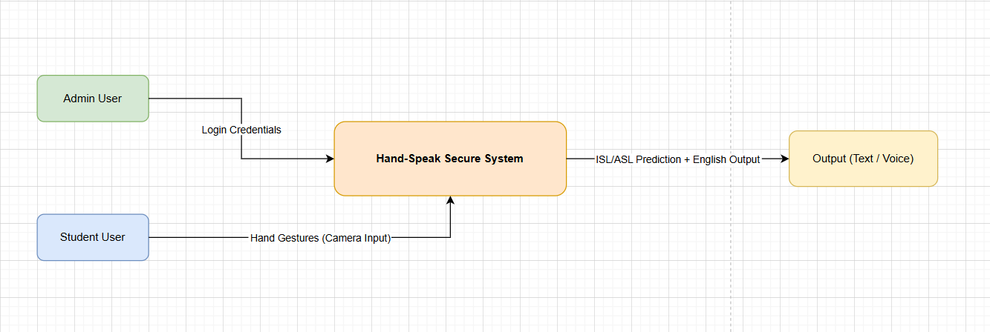

2.2 DFD Level 1

Fig 2.2 Shows gesture flow from camera → processing → classification.
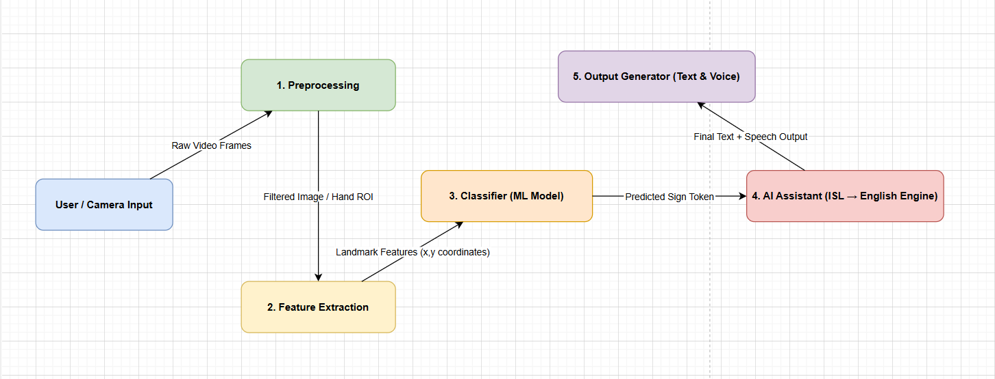

2.3 DFD Level 2

Fig 2.3 Detailed internal logic of gesture recognition.
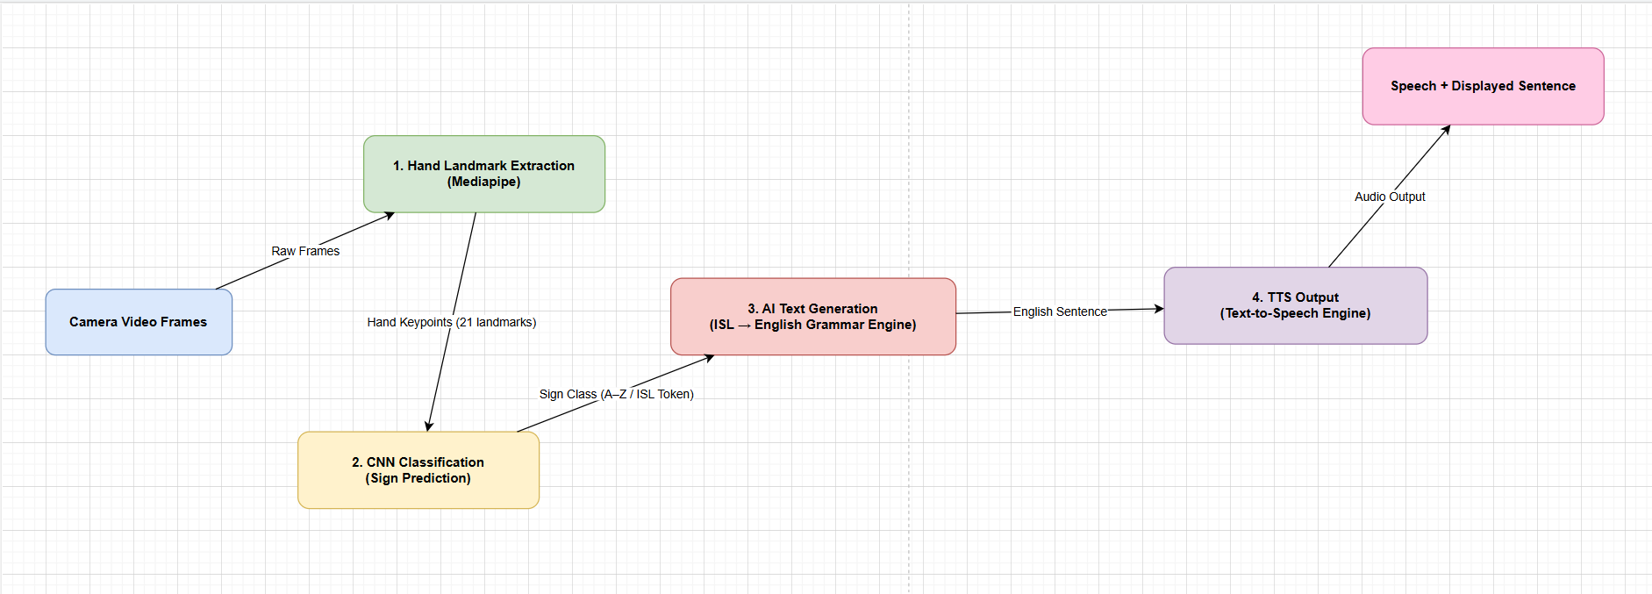

2.4 Use Case Diagram

Fig 2.4 User, admin & authentication server interactions.
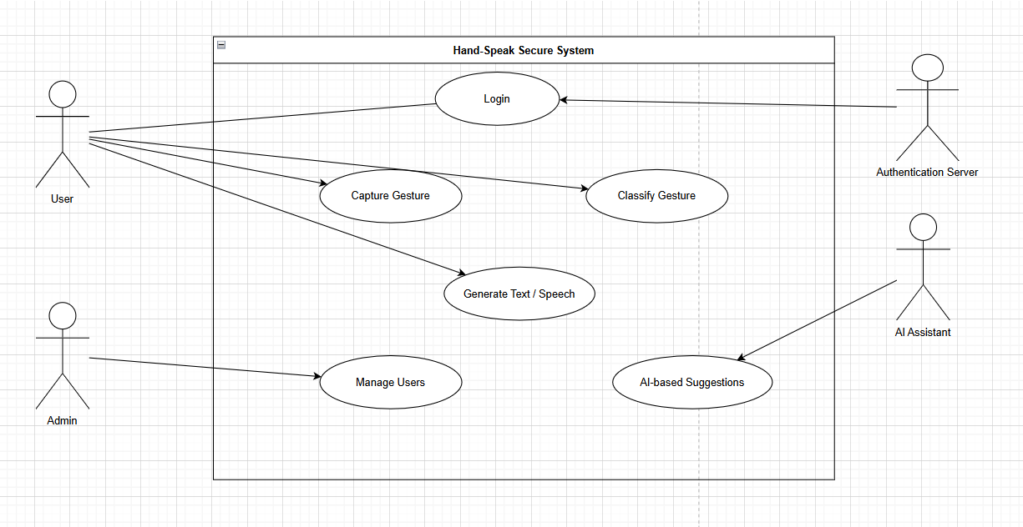
2.5 Class Diagram
Fig 2.5 Defines classes: User, Authentication, FeatureDetector, CNNModel, Logger, etc.
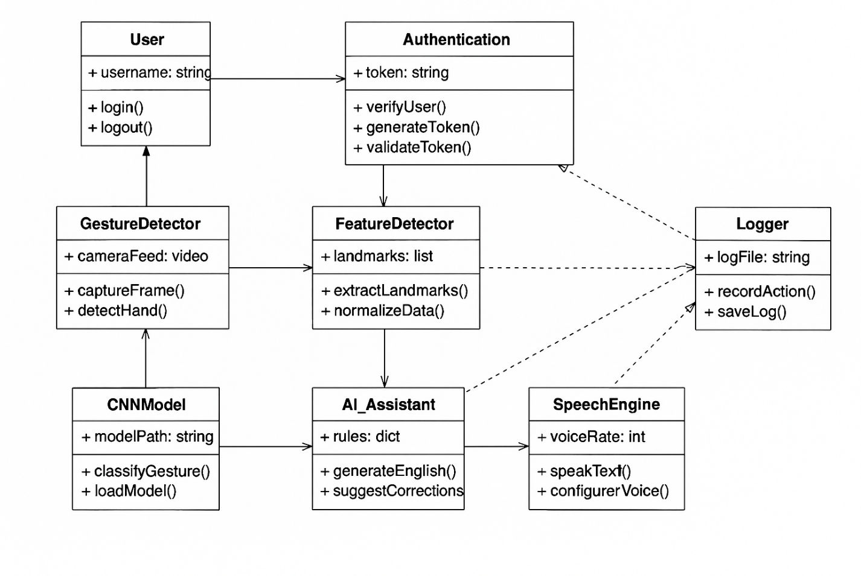

2.6 Sequence Diagram

Fig 2.6 Sequence of steps from gesture detection to speech output.
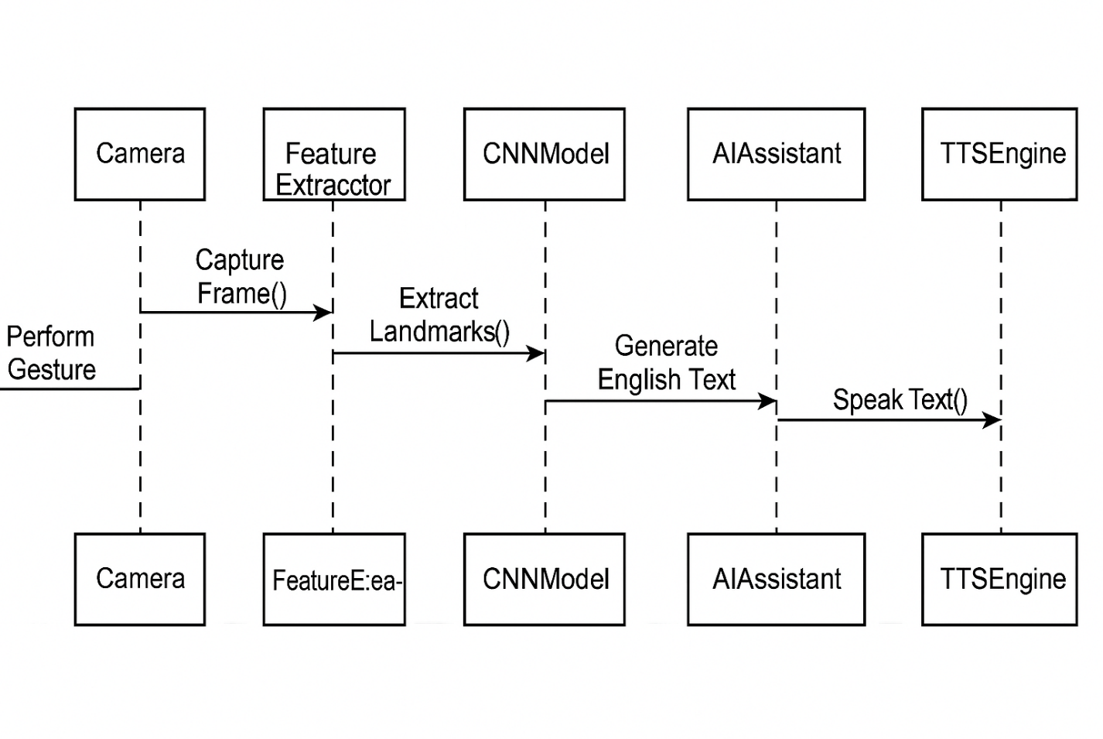

2.7 System Architecture Diagram
Fig 2.7 Complete architecture pipeline of HandSpeak.
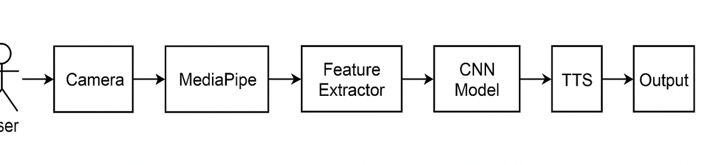
3. DATA DICTIONARY

3.1 Database Tables

Table 3.1 – USERS Table
Field Name | Type | Description | Constraint
user_id | Integer | Unique user identifier | Primary Key
username | Text | Username for login | Unique, Not Null
password_hash | Text | Encrypted password | Not Null
role | Text | admin / user | Default: user
created_at | Datetime | Account creation time | Not Null

Table 3.2 – LOGS Table
Field Name | Type | Description | Constraint
log_id | Integer | Unique log entry ID | Primary Key
user_id | Integer | User who performed action | Foreign Key
gesture | Text | Recognized sign gesture | Not Null
ai_output | Text | AI-generated text response | Optional
timestamp | Datetime | Date & time of recognition | Not Null

Table 3.3 – SESSIONS/AUTH Table
Field Name | Type | Description | Constraint
token_id | Integer | Unique token identifier | Primary Key
user_id | Integer | Reference to user | Foreign Key
access_token | Text | JWT token assigned | Not Null
issued_at | Datetime | Token issue time | Not Null
expires_at | Datetime | Token expiry | Not Null

4. IMPLEMENTATION

4.1 Screen Layouts
🎯 Insert your screenshots here:
- Login Screen 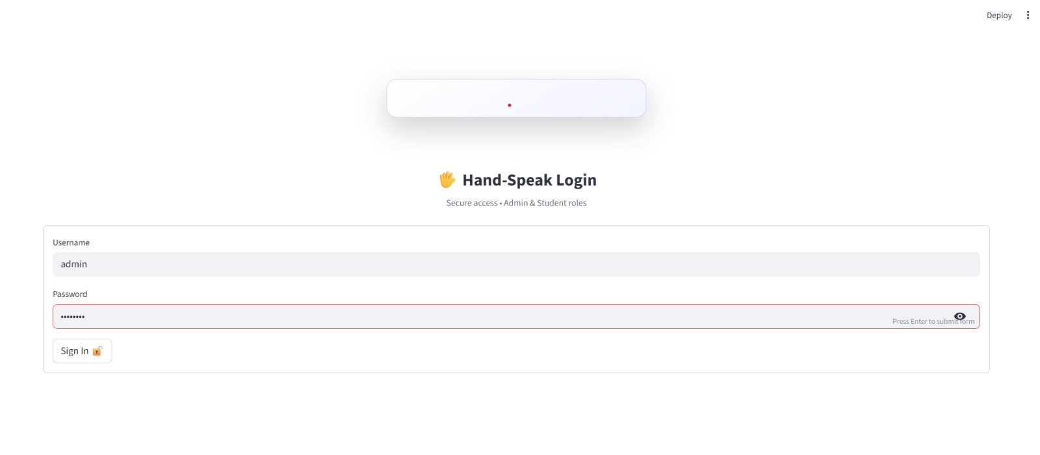
- Dashboard
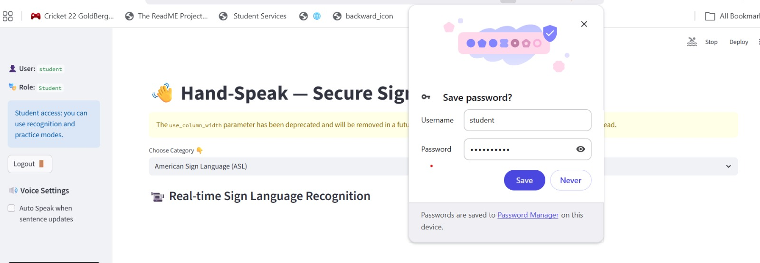
- Camera Window
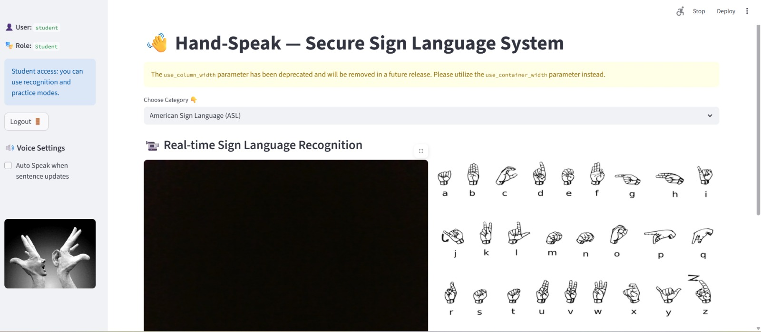
- Real-Time Gesture Detection
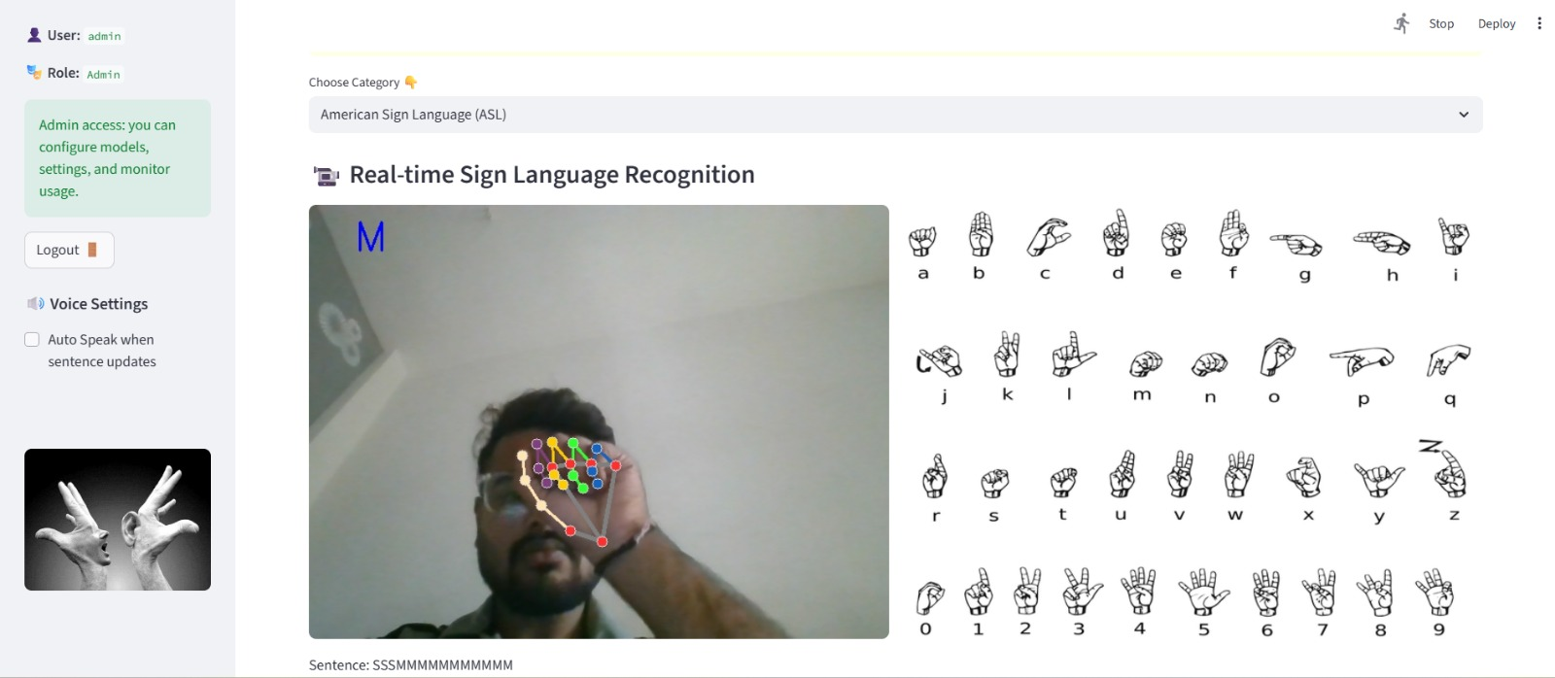

4.2 Sample Coding
- JWT Authentication :-
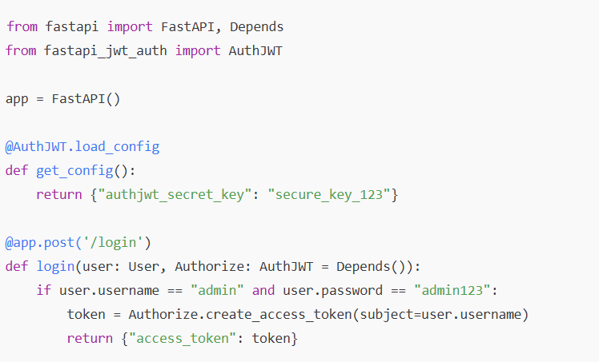
- Gesture Recognition Code :-
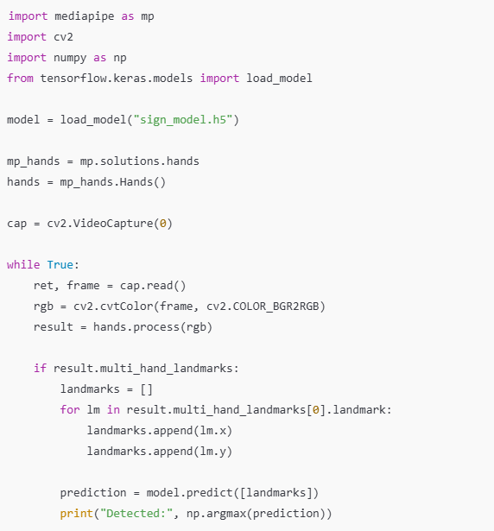

- AI Assistant (OpenAI or Local Model) :-
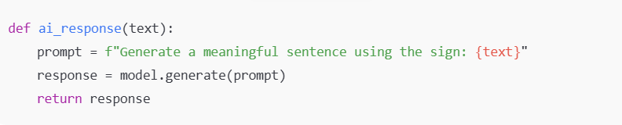

4.3 Steps of Execution

1. Start Backend Server
The backend server (Flask/FastAPI) is started first so that all APIs such as gesture prediction, login authentication, and AI generation become active. The server loads the trained CNN model into memory.

2. Launch Streamlit UI
The user interface is launched through Streamlit, which connects with the backend APIs. This provides access to login, dashboard, camera window, and settings options.

3. Login Authentication
The user logs in using credentials. The system verifies the username and password, generates a JWT token, and grants access based on user roles (admin/user).

4. Grant Camera Access
After login, the system requests permission to access the webcam. Once allowed, real-time video frames are sent for processing.

5. Detect Gestures
MediaPipe processes each frame to extract 21 hand landmarks. These landmarks are normalized and passed to the feature extraction stage.

6. CNN Model Predicts Class
The extracted features are forwarded to the pre-trained CNN model, which classifies the gesture into a specific sign language label such as A, B, Hello, Thank You, etc.

7. AI Generates Response
Based on the predicted gesture, the AI Assistant creates a meaningful sentence or contextual message, enhancing the communication experience for the user.

8. Output Displayed as Text and Speech
The final recognized sign is displayed on the screen along with the AI-generated sentence. The text is then converted into speech using the TTS module for audio output.

Table 4.1 – Model Performance Metrics
Metric | Value
Training Accuracy | 96%
Validation Accuracy | 94%
Training Loss | 0.12
Validation Loss | 0.18
Epochs Trained | 20
Model Size | 8 MB

Table 4.2 – Security Features Implemented
Security Feature | Description | Purpose
JWT Authentication | Login generates secure token | Protects API access
Password Hashing | bcrypt for password storage | Prevents plain-text credential leaks
Role-Based Access | Admin & User roles | Restricted functions for normal users
HTTPS Encryption | Secure data transmission | Protects video & text data
API Protection | Token required for prediction API | Avoids unauthorized model use
Log Monitoring | Admin can track actions | Prevents misuse behaviors

Table 4.3 – API Endpoints & Security Levels
API Endpoint | Functionality | Security Level
/login | Authenticates user | Public
/predict_gesture | Returns predicted gesture | Protected (JWT)
/generate_sentence | AI assistant output | Protected (JWT)
/tts | Text-to-speech generation | Protected
/get_logs | Fetch logs (Admin only) | Admin-Restricted
/add_user | Add new user | Admin-Restricted

4.4 Model Training & Evaluation Results
4.4.1 Model Training Accuracy Graph
- American Sign Language (ASL)
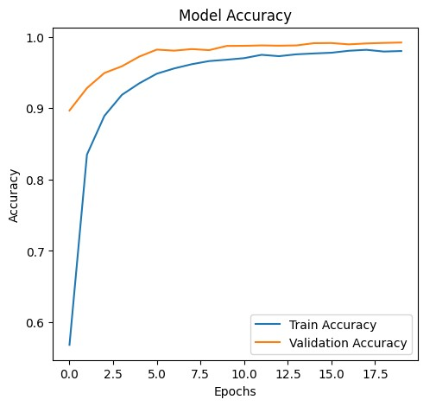

- Indian Sign Language (ISL)
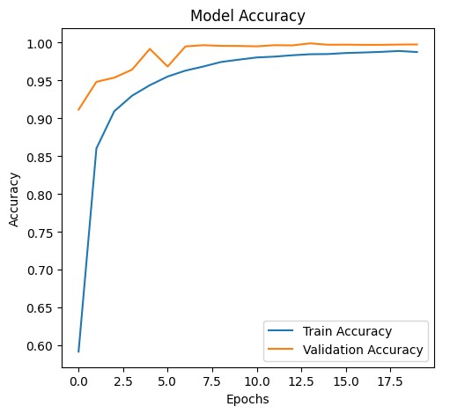

4.4.2 Model Training Loss Graph
1. American Sign Language (ASL)
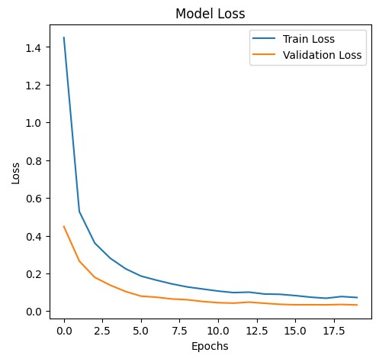
2. Indian Sign Language (ISL)
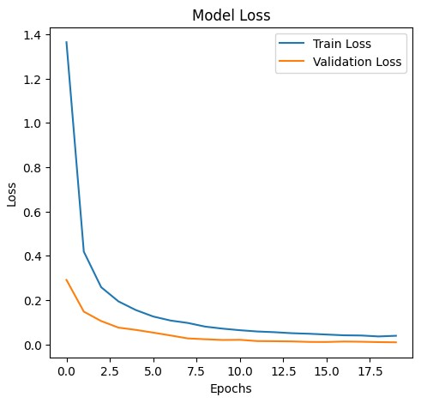

4.5 Python Code
4.5.1 Landmark Detection Code
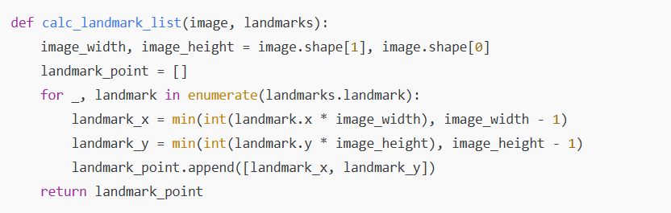
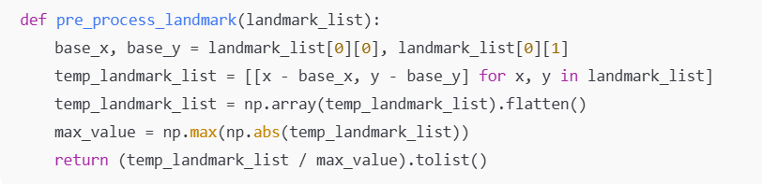
4.5.2 CNN Model Code
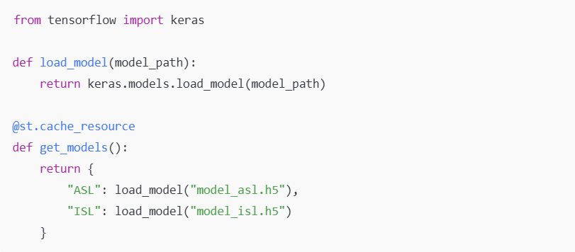
4.5.3 Prediction Code
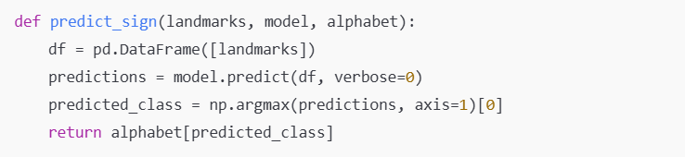
4.5.4 Authentication Code (JWT Security)
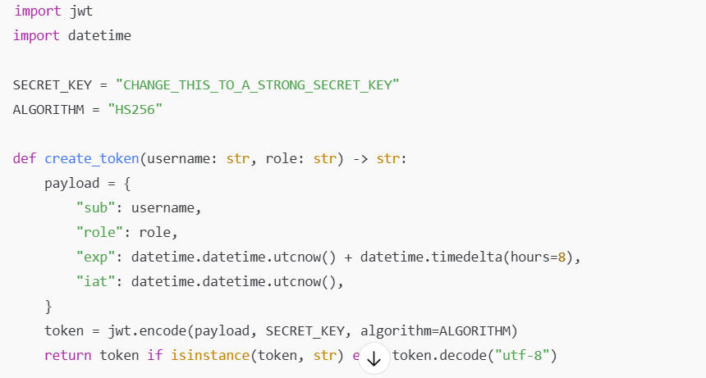
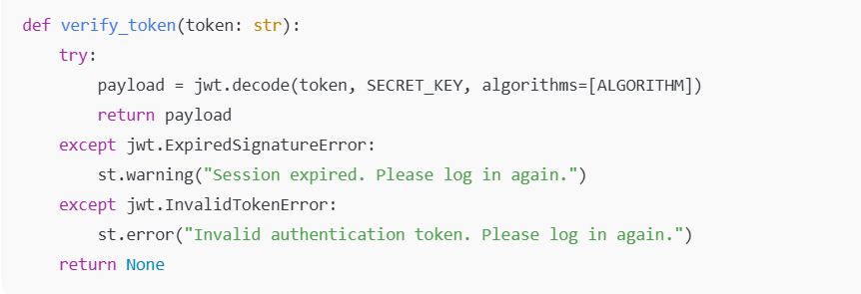
4.5.5 API/Streamlit UI Code
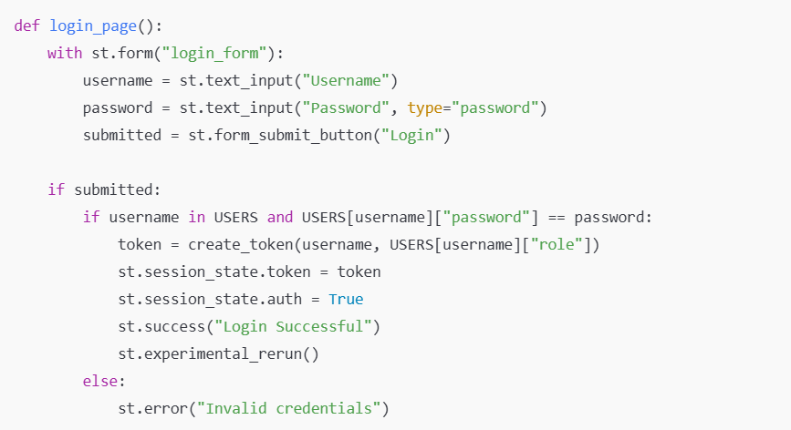
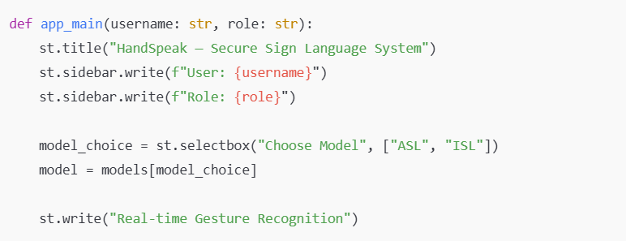
4.5.6 Text-to-Speech (TTS) Code
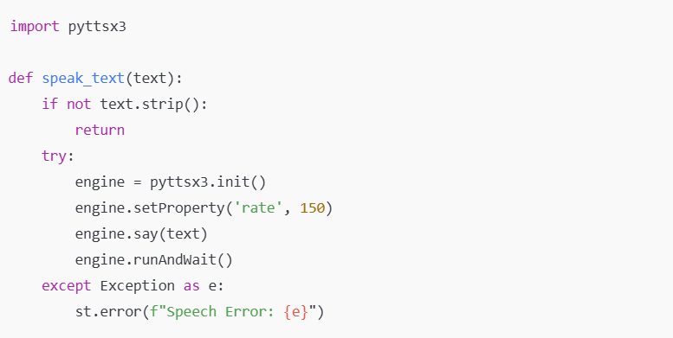

5. CONCLUSION
The HandSpeak system successfully demonstrates how modern technologies such as deep learning, computer vision, and artificial intelligence can be combined to build an effective real-time communication tool for individuals with hearing or speech impairments. By accurately recognizing sign language gestures using a CNN model and MediaPipe-based hand landmark detection, the system bridges the communication gap between sign language users and non-signers.
The integration of an AI Assistant further enhances the usability of the system by generating meaningful sentences based on detected gestures, enabling more natural and fluent interaction. Additionally, the gesture-to-speech module ensures that communication is smooth, fast, and accessible, even in environments where text-based output may be insufficient.
A major strength of the project is the implementation of strong security measures, including JWT-based authentication, encrypted data handling, and role-based access control. These features ensure that the application is not only functional but also safe, reliable, and suitable for real-world deployment.
Overall, the system provides a scalable and impactful solution that promotes inclusivity, accessibility, and independence for the deaf and mute community. With further enhancements such as mobile deployment, voice-to-sign translation, and larger gesture datasets, HandSpeak has the potential to evolve into a widely used assistive technology in educational institutions, healthcare centers, public services, and everyday communication scenarios.

5.1 Importance of the Worked-Out Tasks
The tasks completed in this project play an important role in building a meaningful and impactful system. Each component directly contributes to solving real-world communication challenges faced by the deaf and mute community. The following points highlight the importance of the worked-out tasks:

1. Practical Use-Case Solving Real-World Disability Problems
This project provides a powerful and practical solution for individuals with hearing or speech disabilities. By converting hand gestures into readable and audible output in real time, it helps improve social interaction, accessibility, and independence for users. The system reduces the communication barrier that exists between sign language users and non-signers.

2. Combines AI, Machine Learning, Computer Vision, and Security
The implementation integrates multiple advanced technologies such as deep learning (CNN), MediaPipe-based computer vision, AI-generated text assistance, and secure authentication mechanisms. This combination demonstrates the ability to apply multi-disciplinary technical knowledge to solve a single real-world problem effectively.

3. High Industry Relevance
Gesture recognition, AI assistants, and secure web applications are highly in demand across industries such as healthcare, education, smart devices, accessibility solutions, and human–computer interaction. The tasks completed in this project reflect industry practices, making the work valuable for professional growth and future employment opportunities.

4. Scalable for Mobile, IoT, and Wearable Technology
The system design allows easy extension to mobile applications, IoT-based smart gloves, and wearable devices. This scalability ensures the project can grow into a fully functional product in the future. With further optimization, the solution can be deployed in schools, hospitals, public service centers, and emergency services.

5.2 Future Enhancements
The current system provides reliable real-time sign recognition, AI assistance, and secure access, but there is significant scope for improvement and expansion. The following enhancements can further increase the effectiveness, accuracy, and usability of the system:

1. Add Full Sentence Recognition
At present, the system recognizes gestures individually. In the future, continuous gesture recognition can be implemented to detect entire sentences or gesture sequences automatically. This will make the system much more natural and closer to real human communication.

2. Train with More ISL/ASL Gestures
The model can be expanded by including more gestures from both Indian Sign Language (ISL) and American Sign Language (ASL). A larger and more diverse dataset will increase accuracy, improve robustness, and support multilingual sign language variations.

3. Deploy as a Mobile Application
A mobile version of the system can make the solution more portable and accessible. Users will be able to interact through their smartphone cameras, enabling usage in daily-life scenarios such as hospitals, public places, and workplaces.

4. Add Cloud-Based Analytics
Integrating cloud-based analytics will allow storing gesture logs, performance metrics, and usage patterns. This enables real-time monitoring, remote access, user-specific customization, and better large-scale deployment.

5. Voice-to-Sign Module
To achieve fully bidirectional communication, a voice-to-sign feature can be added. This module will listen to a person’s speech and convert it into animated hand signs or visual icons, making communication easier for people with hearing impairments.

6. REFERENCES
[1] Bambang Krismono Triwijoyo, Lalu Yuda Rahmani Karnaen, Ahmat Adil (2023). Deep Learning Approach for Sign Language Recognition. Bumigora University, Indonesia.
[2] K. Mahimanvitha, M. Arathi (2023). Real-Time Sign Language Recognition Using Deep Learning. International Journal for Research in Applied Science and Engineering Technology.
[3] TensorFlow Documentation. TensorFlow: An end-to-end machine learning platform. Available at: https://www.tensorflow.org/
[4] MediaPipe Documentation. Google MediaPipe Hand Tracking Solution. Available at: https://developers.google.com/mediapipe/
[5] OpenCV Documentation. Open Source Computer Vision Library. Available at: https://opencv.org/
[6] Streamlit Documentation. Fast UI Framework for Data and ML Apps. Available at: https://streamlit.io/
[7] FastAPI Documentation. Modern API framework for Python. Available at: https://fastapi.tiangolo.com/
[8] JWT Authentication Documentation. JSON Web Tokens for Secure Authentication. Available at: https://jwt.io/
[9] bcrypt Library Documentation. Password Hashing for Secure Authentication. Available at: https://pypi.org/project/bcrypt/
[10] OpenAI API Documentation (for AI Assistant Component). Generative AI and NLP Models. Available at: https://platform.openai.com/

